# EMMI Session #3: 17-07-2024

By Eya Lahiani

# “Introduction/User Interface” Demo and Work Time

Today began with an in-depth demonstration of the “Introduction/User Interface”. The instructor guided us through various features in the PyMOL interface, focusing on the Top Menu options like File and Display.

We explored the 1EMA protein example, learning essential techniques such as mouse controls, base settings, coloring a ligand, and creating high-quality images using the Draw/Ray Trace function. Following the demonstration, I opened a new PyMOL session, loaded my project protein using its PDB ID code, and practiced these techniques to generate my first PyMOL image. Remembering the critical instruction to save often due to the absence of an undo button, I managed to create a visually appealing image.

I learned that for this:

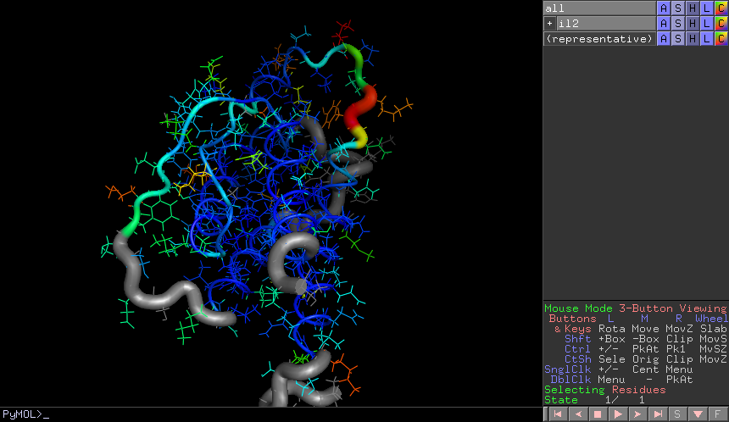

A stands for Action

S stands for Show

H stands for Hide

C stands for Color

Afterward, I experimented with different color and visualization options, further enhancing my understanding of the tool.

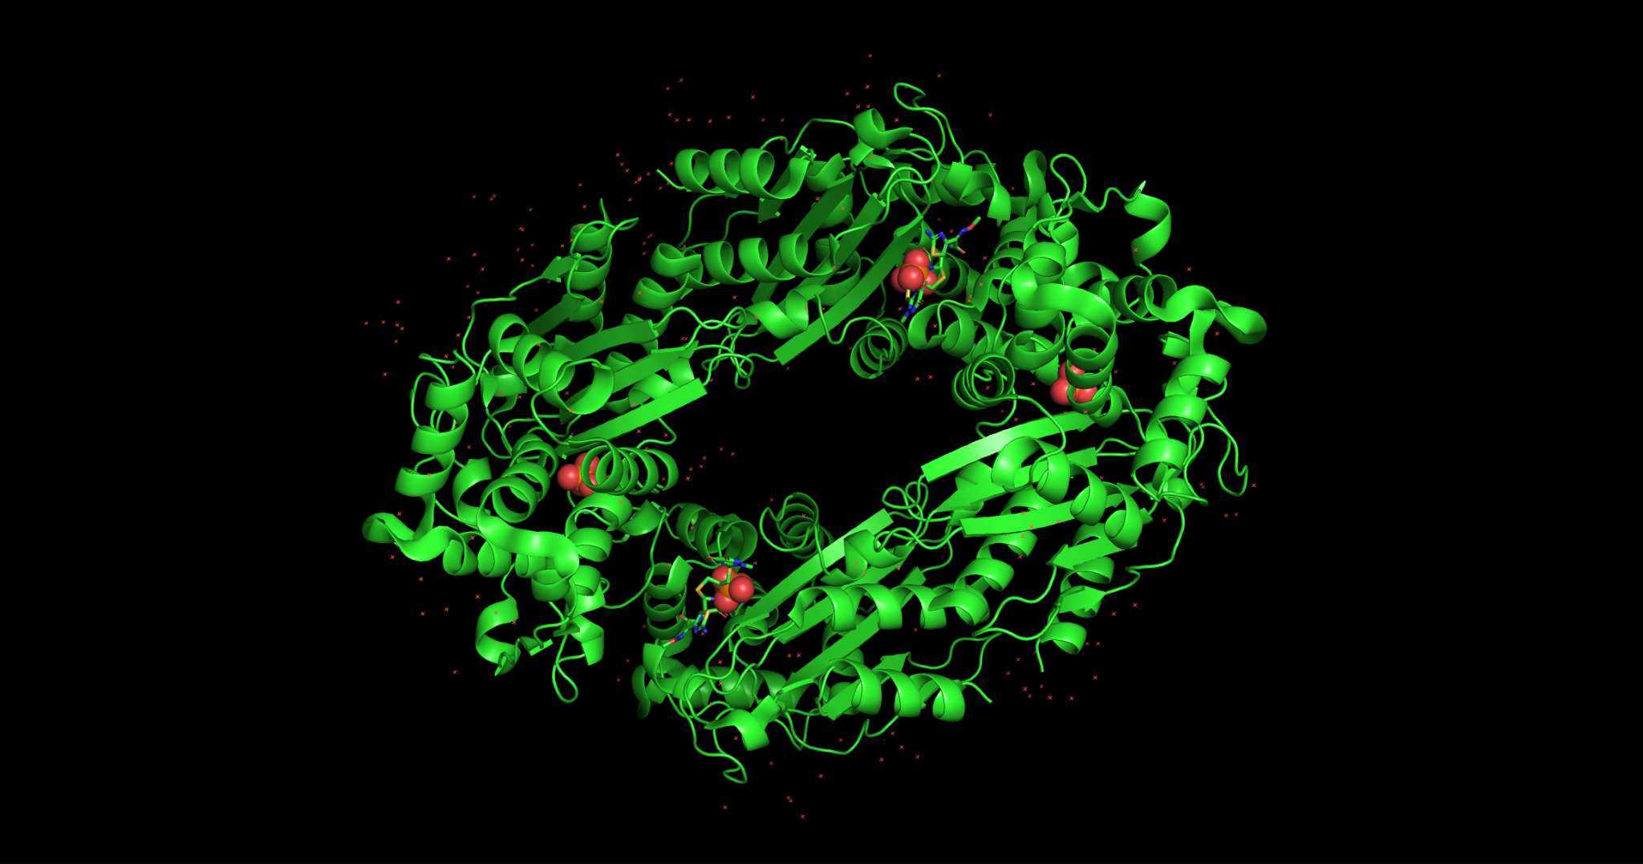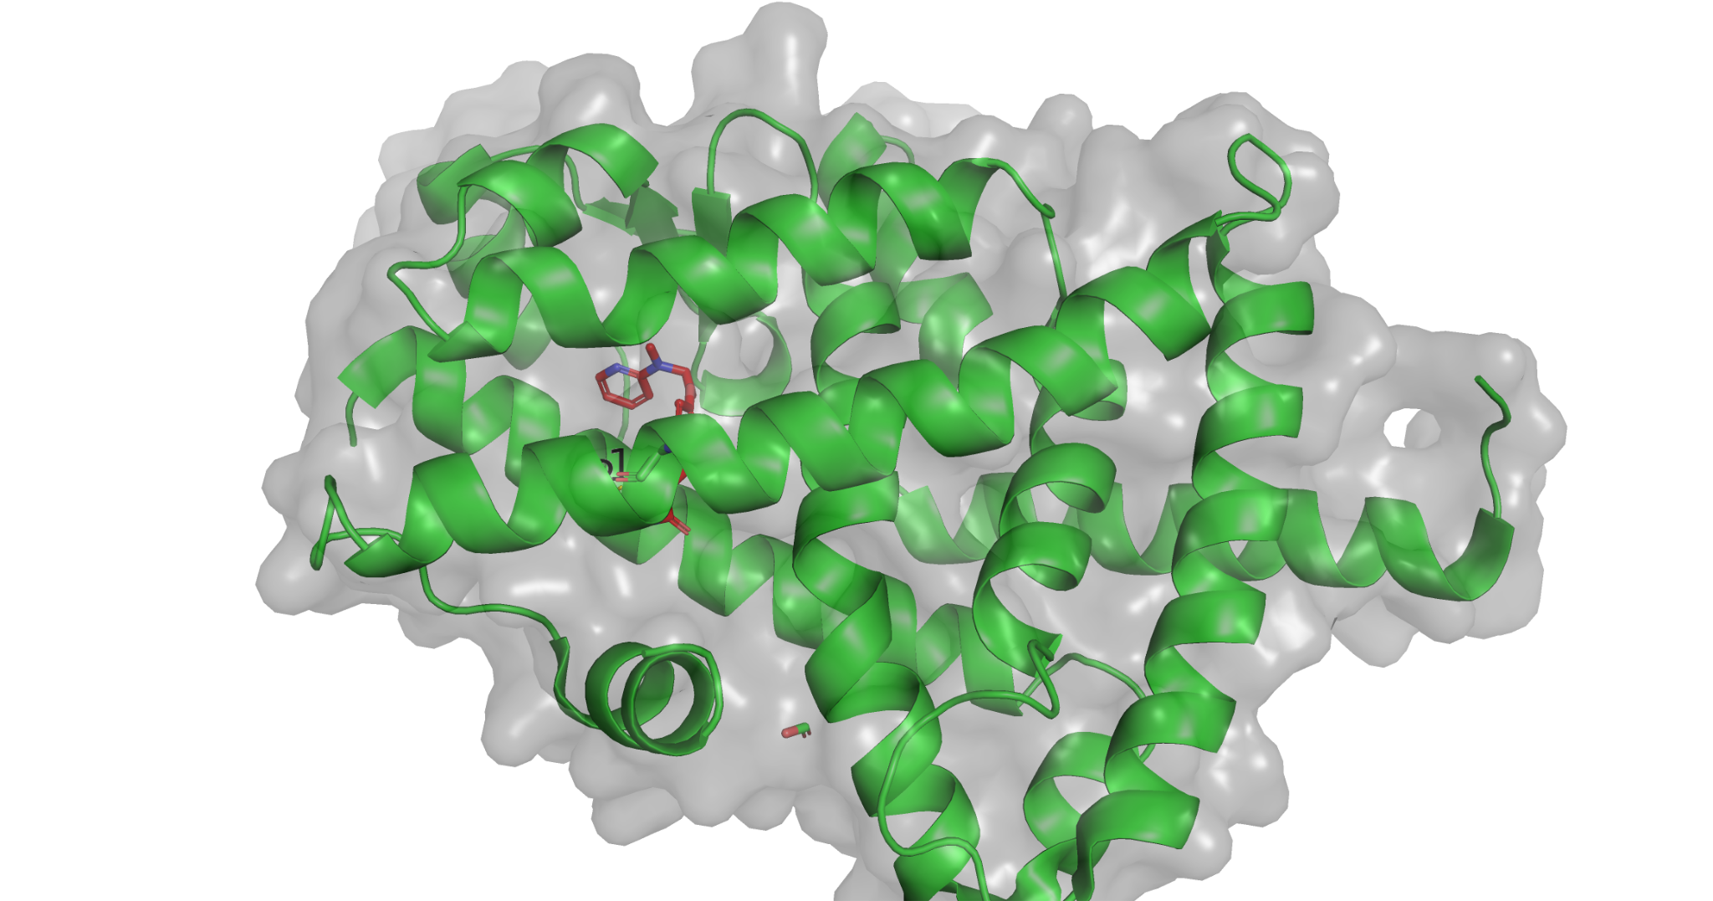

**“Measurements and Labeling” Demo and Work Time**

Later, we delved into “Measurements and Labeling”. The focus was on mutagenesis, labeling residues, and selecting appropriate colors for visualization. I returned to my PyMOL session with the project protein and applied these new techniques.

I made an image featuring three measurements between the ligand and protein, identified some potential hydrogen bonds, and noted the relevant amino acids. Experimenting with color and visualization options continued to be both fun and educational, allowing me to refine my images and better understand the molecular interactions.

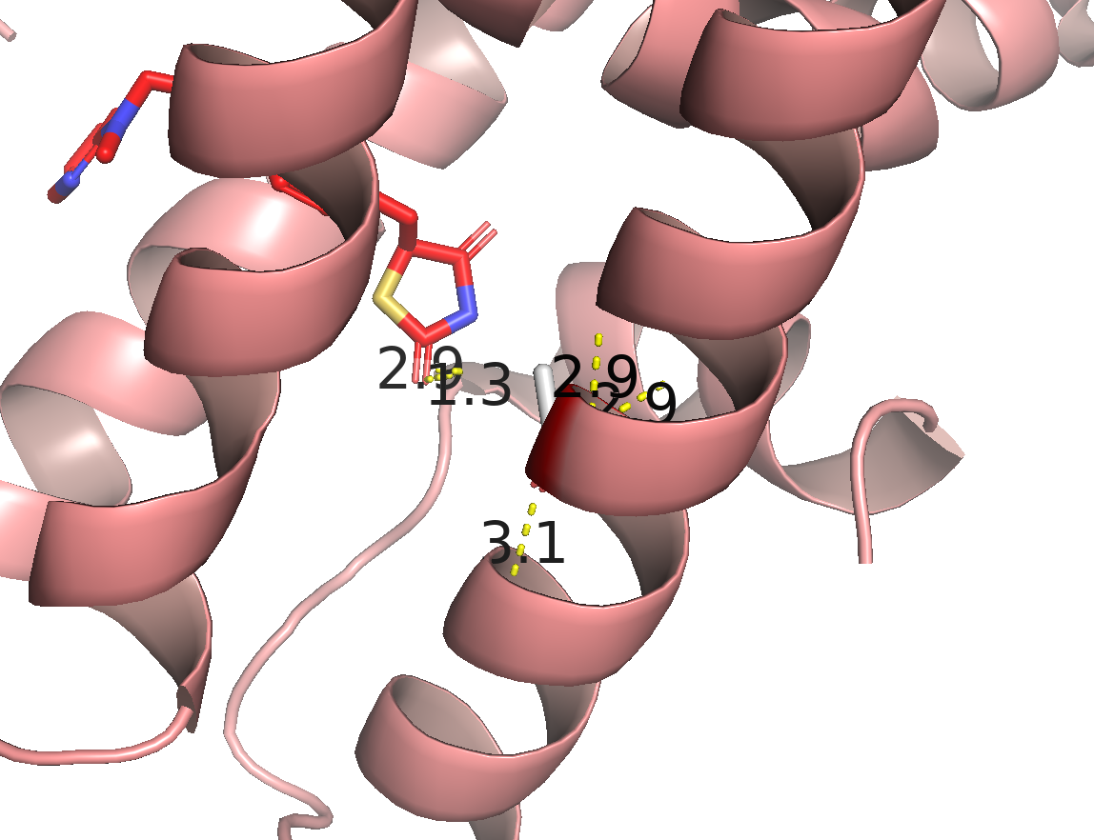

# Control and Test Experiments

For our control experiment, we replicated our team’s crystal structure to observe how the ligand binds to the protein. This exercise was crucial in establishing a baseline for our experiments.

For the test experiment, we had two options for project variables:

1. Assessing how a different small molecule binds to the protein compared to the original ligand, exploring scenarios like Agonist/Activator to Antagonist/Inhibitor or Ligand to Similar Ligand.
2. Evaluating the impact of a single residue mutation on ligand binding, such as changing a Positively Charged Residue to a Negatively Charged Residue or swapping a Non-Polar Residue with a different Non-Polar Residue.

I chose the first option, focusing on how an antagonist would bind compared to the original agonist. This comparison provided valuable insights into the protein-ligand interact ions and potential effects of different ligands.

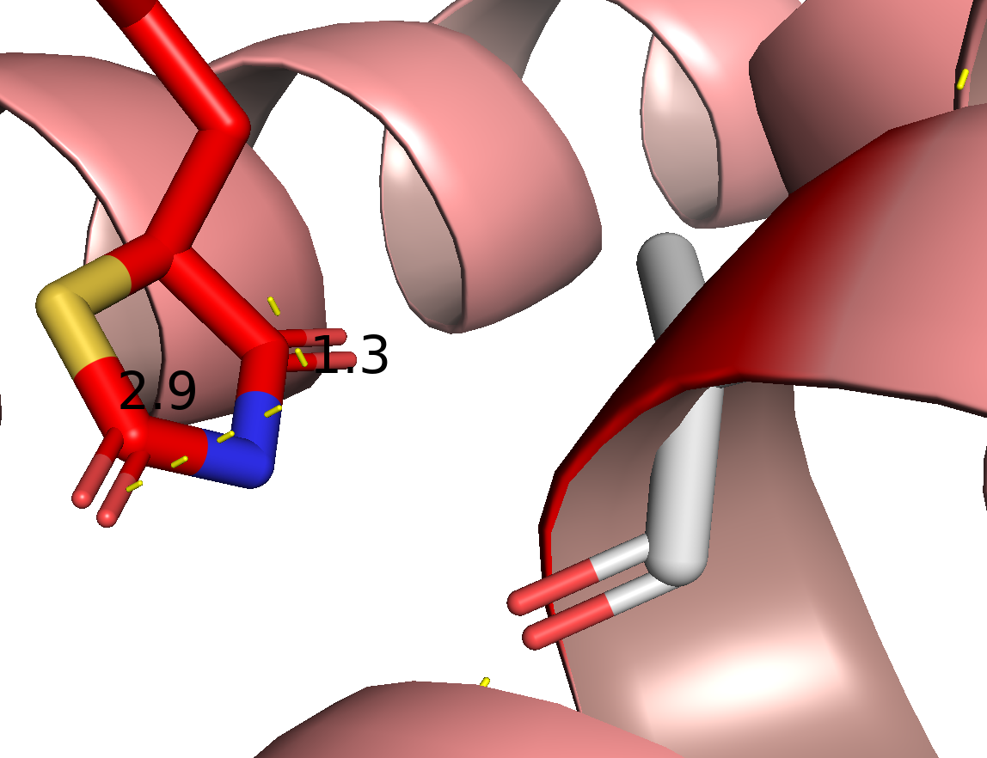

# “Guide to Good Visualizations” Part 1 and RCSB Search

Afterwards, we explored the “Guide to Good Visualizations”. This part emphasized the importance of clear and accurate visual representations in molecular modeling. We also conducted a search on the RCSB (Research Collaboratory for Structural Bioinformatics) database to find additional structures and data that could enhance our projects.

Couple of pyMOL script I learned today:  
select byres 4XLD within 3.5 of ligand #ligand here is a (sele) rename  
select resi449  
set label_size, 30  
set label_connector, 1 #1 is a boolean here as opposed to 30 in the previous example  
set label_connector_width, 4  
set_color (new color name here), (square brackets here with the RGB values)  
set ray_trace_mode, 3  
set cartoon_highlight_color, …

# “Guide to Good Visualizations” Part 2

The day concluded with the second part of the “Guide to Good Visualizations.” This session built on the previous one, offering advanced tips and techniques for creating high-quality molecular visualizations. These guidelines are crucial for effectively communicating our findings and ensuring that our visual representations are both scientifically accurate and visually compelling.

We also learned to work with scenes, timeline, cartoon transparency, export animation and so on…

# Final Thoughts:

Overall, today was incredibly productive and informative, providing me with valuable skills and techniques in molecular visualization using PyMOL. I'm excited to apply these new insights to my ongoing project and see the results of our experiments.

# Gallery:

